**Project Proposal**

**Data Visualization of Crime Patterns in Toronto During the COVID-19 Pandemic**

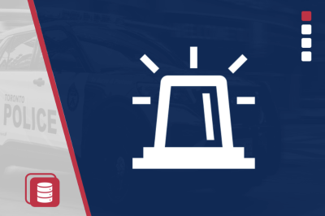

**Overview**

The COVID-19 pandemic led to substantial changes in the daily activities of millions of Canadians, with many businesses and schools closed, public events canceled and new rules introducing stay-at-home orders. Our project will focus on visualizing the impact of the COVID-19 pandemic on crime patterns in Toronto. To accomplish this,this project will gather data to understand how the frequency of common types of crime changed in Toronto during, before and after the covid 19 pandemic.

## **Objectives**

1. **Analyze Crime Rate Trends**:  
   Compare the frequency of common types of crimes in Toronto before, during, and after the COVID-19 pandemic to identify significant trends and patterns.
2. **Geospatial Analysis**:  
   Visualize geographic shifts in crime hotspots during the pandemic using interactive maps.

## **Tools & Technologies**

* **Visualization Libraries**: Plotly (JavaScript) and a Python library
* **Database**: PostgreSQL to store and retrieve crime data.
* **Interaction**: HTML menus and dropdowns for user-driven data filtering and visualization.

## **Data Source**

* Toronto Police Service crime data, with at least 100 records, covering periods before, during, and after the COVID-19 pandemic.

## **Expected Outcomes**

* A clear understanding of how the COVID-19 pandemic affected crime patterns in Toronto.
* Visualizations and data-driven insights into geographic shifts in crime.

## **Expected Deliverables**

* **Interactive Visualizations**: At least three views, including temporal and geospatial analyses.
* **User Interaction**: HTML-based interface for filtering and visualizing data.
* **README.md**: Overview, usage instructions, ethical considerations, and references.

**Timeline**

**Days 1-2**: Data Collection & Database Setup

**Days 3-4**: Initial Data Analysis

**Days 5-6**: Visualization Development

**Day 7**: Add Interactive Features

**Day 8**: Refinement & Testing

**Day 9**: Final Report & README.md

**Day 10**: Presentation Preparation

## **Conclusion**

This project will provide valuable insights into how the COVID-19 pandemic influenced crime patterns in Toronto, informing future public safety strategies during public health crises.



|  |
| --- |
| **Data Sources:**  <https://data.torontopolice.on.ca/pages/open-data>  [https://www150.statcan.gc.ca/t1/tbl1/en/tv.action?pid=3510002601&pickMembers%5B0%5D=1.19&cubeTimeFrame.startYear=2019&cubeTimeFrame.endYear=2021&referencePeriods=20190101%2C20210101](https://www150.statcan.gc.ca/t1/tbl1/en/tv.action?pid=3510002601&pickMembers%255B0%255D=1.19&cubeTimeFrame.startYear=2019&cubeTimeFrame.endYear=2021&referencePeriods=20190101,20210101)  <https://open.toronto.ca/dataset/covid-19-cases-in-toronto/>  https://open.toronto.ca/ |
| **Team Members**  Neal L, Lavanya B, Mahnaz K, Julian P, Rasadari R |
|  |